
MINI PROJECT OF EE6483 DOGS VS CATS

Director: Wen Bihan

Group Member 1: SUN SI YUAN (G2506227B)
SIYUAN019@e.ntu.edu.sg
Group Member 2: SHI RANGBING (G2501504F)
RANBING001@e.ntu.edu.sg
Group Member 3: QIAN ZHENGHE (G2500892F)
QIAN0108@e.ntu.edu.sg

SCHOOL OF ELECTRICAL AND ELECTRONIC ENGINEERING
2026

Content
1 Introduction 4
2 Literature Survey 4
2.1 Background of Image Classification 4
2.2 Recent Progress and Key Literature 4
2.3 In-depth Analysis of Representative Works 5
2.4 Baseline Selection and Motivation 5
3 Data Preparation 6
3.1 Dataset Overview 6
3.2 Pre-processing 6
3.3 Data Augmentation 6
4 Model Architecture and Training Strategy 7
4.1 Primary Model: ResNet-50 via Transfer Learning 7
4.1.1 Model Architecture and Structural Innovations 7
4.1.2 Loss function and optimization 8
4.1.3 Training Strategy 9
4.1.4 Reproducibility and Determinism 9
5 Hyperparameter Tuning and Optimization Strategy 11
5.1 ResNet- 50 Hyperparameter Ablation 11
5.1.1 Learning Rate 11
5.1.2 Batch Size 11
5.1.3 Hyperparameter Selection Summary 12
5.1.4 Early Stopping 12
5.1.5 Plot Loss Curve 12
5.2 Classification Results on Validation Set 13
6. Analysis of validation set evaluation metrics and explanation of testing set inference 14
6.1 Detailed Classification Report 14
6.2 In-depth Analysis of the Confusion Matrix 14
6.3 Generation and Submission of Test Set Results 15
7. Qualitative Analysis of Correct and Incorrect Samples (Bad Cases) 16
7.1 Analysis of Correctly Classified Samples 16
7.2 In-depth Analysis of Misclassified Samples (Bad Case Analysis) 16
7.3 Summary of the Model’s Overall Strengths and Weaknesses 18
8.Comparative Analysis of Model Architectures and Data Processing Strategies 18
8.1 Comparative Analysis of Model Architectures and Pre-training 18
8.2 Ablation Studies on Data Augmentation Strategies 19
9. CIFAR-10 Multi-classification Extension Experiment and Analysis 20
9.1 Dataset Description and Task Challenges 20
9.2 Model Modifications and Architecture Adaptation 21
9.3 Training Process and Overall Results 21
9.4 Fine-grained Category Performance Analysis 22
10. An Analysis of Strategies and Results for Addressing Class Imbalance in CIFAR-10 23
10.1 Simulation of Real-World Scenarios and Problem Statement 23
10.2 In-depth Analysis of the Principles Behind the Countermeasures 23
10.3 Results of Strategy Ablation Experiments 24
10.4 In-depth Comparison and Analysis of Causes 24
11. Member Allocation of Responsibilities and Tasks.........................................................25
Reference list: 26
Appendix_A----Source_Code:...............................................................................................27

1 Introduction
This project aims to develop a robust algorithm to classify whether an image contains either a dog or a cat.[1] The dataset utilized for this task comprises 20,000 training images and 5,000 validation images across the two classes, along with 500 images that need to be classified in the test set. To achieve optimal classification performance, we design and develop a classification model by implementing and evaluating three distinct neural network architectures: a baseline Simple CNN, a ResNet-50 trained from scratch, and a primary ResNet-50 model initialized with pre-trained weights. Our methodology incorporates comprehensive data processing procedures and image augmentations, including resizing, random cropping, horizontal flipping, rotation, and Color Jitter, to improve generalization. Furthermore, extensive ablation studies were conducted to test different model parameters, specifically focusing on the learning rate, and to evaluate the independent impact of various data augmentation techniques.
Finally, the proposed classification algorithm is applied to a multi-category image classification problem for the CIFAR-10 dataset. Within this context, we deliberately simulate a scenario with much fewer labelled data for certain classes to tackle the data unbalancing issue. To resolve this, we propose and justify two approaches: Weighted Random Sampling and a Class-Weighted Cross-Entropy Loss function.

2 Literature Survey

2.1 Background of Image Classification
Image classification is a fundamental task in computer vision, defined as assigning a categorical label to an input image based on its visual content. Despite significant advancements, robust classification remains difficult due to inherent challenges such as intra-class variation, inter-class similarity, scale variations, background clutter, and shifting illumination conditions.
Researchers evaluate models under various experimental settings to address these challenges. Supervised learning relies on annotated datasets to train models, whereas unsupervised learning attempts to discover hidden structural representations without explicit labels. Models are typically tested in a closed-set environment, where training and testing classes are identical. Open-set recognition, conversely, requires the model to identify when it encounters a novel, previously unseen class during inference. Additionally, domain shift introduces another challenge: a model trained on idealized data may fail on real-world photographs, necessitating domain adaptation techniques to bridge the gap between differing data distributions.

2.2 Recent Progress and Key Literature
The trajectory of modern image classification is largely defined by the evolution of deep learning architectures, transitioning from early Convolutional Neural Networks (CNNs) to recent attention-based models. A brief chronological overview of highly cited breakthroughs is provided below:
- 2012 - Alex Net: Pioneered the application of deep CNNs for large-scale visual recognition, significantly outperforming traditional methods on ImageNet.[2]
- 2014 - VGGNet: Demonstrated that network depth is crucial, using uniform 3×3 convolutional filters to build highly effective feature extractors.[3]
- 2016 - ResNet: Introduced residual connections to solve the vanishing gradient problem, enabling the training of exceptionally deep networks.
- 2019 - EfficientNet: Proposed a compound scaling method that uniformly scales network width, depth, and resolution for better accuracy and efficiency.[6]
- 2020 - ViT: Adapted the Transformer architecture natively to image patches, challenging the dominance of CNNs in visual tasks.[7]
- 2021 - Swin Transformer: Introduced hierarchical shifted-window attention, establishing a new highly efficient benchmark for general-purpose vision backbones.[8]

2.3 In-depth Analysis of Representative Works
Among the architectures developed in recent years, Deep Residual Networks (Reset) and Vision Transformers (ViT) represent two fundamentally different but highly successful paradigms.
Prior to ResNet, stacking more layers in a CNN generally led to a degradation problem where accuracy saturated and then degraded rapidly due to vanishing gradients. ResNet solved this by introducing residual learning. Instead of expecting stacked non-linear layers to fit an underlying mapping $H(x)$, the architecture forces these layers to fit a residual mapping, $F(x) = H(x) - x$. This is realized through "shortcut connections" that skip one or more layers. This structural change allowed for the successful training of networks ranging from 18 layers (ResNet-18) up to 152 layers, leading to state-of-the-art performance while maintaining lower computational complexity than VGG architectures.
Conversely, the Vision Transformer (ViT) shifts away from convolutions entirely. Its core methodology involves splitting an image into fixed-size patches, linearly embedding them, and feeding the resulting sequence of vectors into a standard Transformer encoder with self-attention mechanisms. This allows the model to capture global contextual information from the very first layer. While ViT requires massive amounts of data to outperform ResNet due to its lack of inductive bias, it demonstrates superior scalability when such data is available.

2.4 Baseline Selection and Motivation
To classify whether an image contains a dog or a cat, we implement a two-stage modeling approach. First, a is selected as the initial baseline. This lightweight architecture allows us to verify the integrity of our data preprocessing pipeline and Simple CNN establishes a fundamental performance benchmark without requiring extensive computational resources.
For the primary classification architecture, we select ResNet-18. While extremely deep models like ResNet-50 or data-hungry architectures like ViT are powerful, they are highly prone to overfitting on medium-sized datasets (such as our 20,000 training images) and incur unnecessary computational overhead. ResNet-18 strikes an optimal balance: it leverages the proven residual connections to ensure stable gradient flow and utilizes pre-trained weights from ImageNet for robust feature extraction, yet its parameter count remains manageable.
To further improve the proposed ResNet-18 solution, standard data augmentation is insufficient. We motivate the implementation of advanced augmentation strategies, specifically Auto Augment and Color Jitter. By artificially increasing the diversity of the training data distribution, these improvements aim to mitigate overfitting and enhance the model's generalization capabilities on challenging test samples involving occlusion or poor lighting.

3 Data Preparation

3.1 Dataset Overview
The research utilized the provided Dogs vs. Cats dataset, which is partitioned into training, validation, and test sets. In the training and validation sets, there are two kinds of labelled images, namely dog and cat. The utilized training set contained a total of 20,000 images, perfectly balanced and divided into 10,000 cat images and 10,000 dog images. The validation set comprised 5,000 images, including 2,500 cat images and 2,500 dog images, which were used to monitor generalization and prevent overfitting. The test set included 500 images that were unlabeled and used exclusively to test the final classification performance. During the research, all the available images in the training and validation sets were fully utilized to maximize the learning capacity.

3.2 Pre-processing
The transform pipeline is meticulously designed to align inputs with ImageNet-pretrained backbones while injecting just enough stochastic variation during training to improve generalization. At evaluation and inference time, it remains fully deterministic: each RGB image is directly resized to a fixed resolution of 224 ×224. The pixel values are converted from 8-bit integers to floating-point tensors via 𝑥 = 𝐼/255, and standardized channel-wise with ImageNet statistics 𝑥𝑐′ = (𝑥𝑐 − 𝜇𝑐)/𝜎𝑐 where 𝜇 = (0.485, 0.456, 0.406) and 𝜎 = (0.229, 0.224, 0.225) for 𝑐 ∈ {𝑅, 𝐺, 𝐵}. This sequence fixes the field of view, removes evaluation randomness, and matches the distribution assumed by ResNet-50.

3.3 Data Augmentation
During training, the same normalization bookends a series of controlled augmentations that preserve semantics while broadening data coverage. Images are first resized to 256 × 256 to provide a spatial margin, and then passed through a Random Crop to the target size of 224 × 224, jointly perturbing the viewpoint and acting as a spatial translation regularizer. A horizontal flip with probability 0.5 introduces left-right invariance, which is semantically appropriate for orientation-agnostic classes like pets. Furthermore, a random in-plane rotation 𝜃 ∼ 𝑈[−15∘, 15∘] improves robustness to camera tilt without introducing large padding artifacts. Finally, a mild ColorJitter perturbing brightness, contrast, and saturation by ±20% encourages the model to rely on shape and structure rather than brittle photometric cues, after which tensors are created and normalized exactly as in evaluation to maintain distributional consistency.
These augmentations introduced essential variability in scale, orientation, and illumination, improving the model’s ability to recognize images under diverse conditions. All preprocessing steps and augmentations were implemented using PyTorch’s transforms module. The corresponding code is shown below:
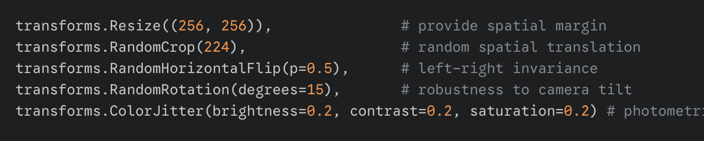
Figure 3.1：The corresponding code

4 Model Architecture and Training Strategy
In this study, a progressive modeling approach was established for the binary classification task. Specifically, the methodology involved designing and evaluating three distinct experimental setups: a lightweight baseline SimpleCNN, a ResNet-50 trained from scratch, and a primary highly robust ResNet-50 model initialized with ImageNet pre-trained weights.

4.1 Primary Model: ResNet-50 via Transfer Learning

4.1.1 Model Architecture and Structural Innovations
SimpleCNN is designed as an efficiency-oriented, lightweight prototype. It stacks four sequential convolutional blocks, scaling feature channels progressively (32→ 64→ 128→ 256). Each block contains a 3×3 Convolutional layer, Batch Normalization, and a ReLU activation function, followed by a 2×2 Max-Pooling layer for spatial downsampling. An Adaptive Average Pooling layer (1× 1) converts the final feature maps into a flattened 256-dimensional vector. This vector feeds into a shallow classifier head featuring Dropout (p=0.5) and a final Linear layer. This design ensures rapid prototyping, low parameter count, and robust convergence for baseline benchmarking.
To tackle the binary classification task effectively, we adopted a transfer learning approach utilizing ResNet-50 as the primary backbone. Proposed by He et al. (2016), [4],[5] ResNet-50 is a deep, robust residual network comprising 49 convolutional layers and 1 fully connected layer, containing approximately 25.6 million trainable parameters.
Unlike shallower networks, training a 50-layer architecture traditionally suffers from the vanishing gradient problem and severe accuracy degradation. ResNet-50 explicitly overcomes this barrier by introducing "Bottleneck" residual blocks. Each bottleneck block utilizes a stack of 1 ×1, 3×3, and 1 ×1 convolutions, significantly reducing computational complexity while restoring dimensionality. More importantly, it employs identity shortcut connections that add the original input x to the transformed output F(x), making the mapping H(x) = F(x) + x. This allows gradients to flow unimpeded directly to earlier layers during backpropagation.
To adapt this powerful ImageNet-pretrained backbone for our specific Dogs vs. Cats dataset, we freeze the initial layers during early training stages to preserve the generalized low-level visual features (e.g., edges and textures). Subsequently, the original 1000-class fully connected output layer is removed. The 2048-dimensional feature vector generated by the Global Average Pooling layer is then fed into a highly customized, multi-stage classification head designed to prevent overfitting on our moderately sized dataset. The specific transformations are detailed in Table 1.
Table 4.1: Detailed Structure of the Custom ResNet-50 Classification Head
Layer | Output Dimension | Description / Role
Input | 3 × 224 ×224 | Standardized RGB input images
ResNet-50 Backbone | 2048-dim | Bottleneck feature extraction (original FC removed)
Dropout (p=0.5) | 2048-dim | Primary regularization, dropping 50% neurons to prevent co-adaptation
Linear(2048→ 256) | 256-dim | Dimensionality reduction
ReLU Activation | 256-dim | Introduces non-linearity to the dense feature space
Dropout (p=0.3) | 256-dim | Secondary regularization before final projection
Linear (256 → 2) | 2 -dim | Final unnormalized logits for Dog / Cat output

4.1.2 Loss function and optimization
We adopt binary cross-entropy for two-class prediction, with targets 𝑦_{𝑖} ∈ {0,1} and predicted probabilities 𝑦̂_{𝑖} ∈ [0,1]. The empirical loss over 𝑁 samples is: The modified ResNet-50 model outputs unnormalized logits for C=2 classes. We adopt the standard binary Cross-Entropy Loss (implemented as CrossEntropyLoss in PyTorch) as the primary optimization objective. Given the true class label 𝑦_{𝑖} ∈ {0,1} and the predicted probability 𝑦̂_{𝑖} ∈ [0,1] after softmax activation, the empirical loss over a batch of N samples is mathematically defined as:
𝑁
𝐿𝑜𝑠𝑠 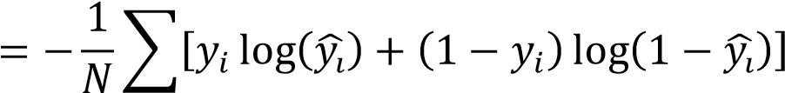 (4.3)
𝑖=1
To drive the optimization process efficiently through the complex loss landscape of a 25.6-million-parameter network, the Adam optimizer is utilized. [9]Adam combines the advantages of AdaGrad and RMSProp by computing adaptive learning rates for each parameter based on estimates of first and second moments of the gradients. We initialize the learning rate at 1 × 10⁻⁴ and apply a weight decay (L2 penalty) coefficient of 1 × 10⁻⁴. This weight decay provides crucial implicit regularization, constraining the magnitude of the network weights and effectively mitigating the risk of overfitting

4.1.3 Training Strategy
The training routine is meticulously designed to maximize generalization. Each epoch consists of a forward-backward training pass where gradients are actively computed, followed immediately by a validation pass strictly executed under model.eval() mode with gradient tracking disabled (torch.no_grad()). Model performance is continuously monitored using the Accuracy metric:
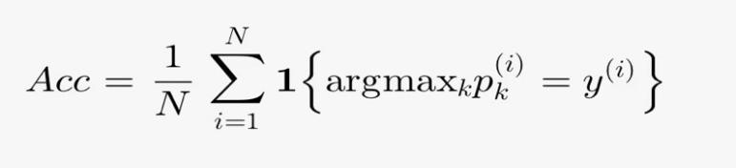
To further refine the learning trajectory, a Cosine Annealing learning rate scheduler (Cosine Annealing R) is integrated. Unlike step-decay, cosine annealing smoothly decreases the learning rate following a cosine curve, starting relatively high to escape sharp local minima and decaying near zero towards the end of the specified epochs to allow for extremely fine-grained convergence.
Additionally, an Early Stopping mechanism is implemented to safeguard against over-training. The algorithm monitors the validation accuracy at the end of each epoch. If the validation performance stagnates and shows no improvement for 5 consecutive epochs (patience = 5), the training loop automatically halts, and the model checkpoint that yielded the highest historical validation accuracy is restored as the final deployment model.
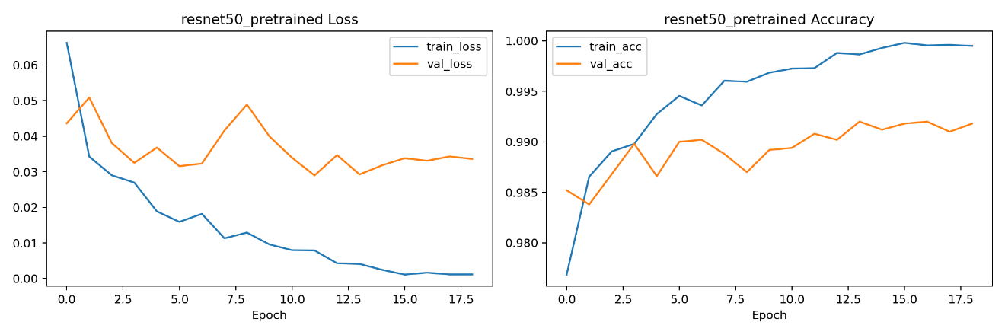
Figure 4.1：resnet50_pretrained loss and accuracy curve

4.1.4 Reproducibility and Determinism
In deep learning experiments, stochasticity can arise from data loader shuffling, parameter initialization, and Dropout layers. To ensure strict run-to-run comparability and exact reproducibility of the reported accuracy metrics, a global random seed is rigidly fixed at 42. This is enforced across all computational levels via torch.manual_seed(42), np.random.seed(42), and by setting torch.backends.cudnn.deterministic = True. The complete implementation of the model architecture, pipeline, and training loop is thoroughly documented and attached in the Appendix (e.g., src/train.py).

5 Hyperparameter Tuning and Optimization Strategy
To achieve the optimal generalization performance for the ResNet-50 model, a systematic hyperparameter tuning process was conducted. The parameters with requires_grad = True are optimized using the Adam optimizer accompanied by an L2 weight decay penalty. Using the learning rate 𝜂, decay coefficient 𝜆, and bias-corrected moment estimates 𝑚̂_{𝑡} ,𝑣̂_{𝑡} and constant 𝜖₀, the parameter update rule at step t is formulated as:
𝑚̂_{𝑡}
θ_{𝑡+1} = θ_{𝑡} − η ( + λ θ_{𝑡}) √𝑣̂_{𝑡} + ϵ₀
Furthermore, to prevent the model from getting trapped in sharp local minima and to encourage fine-grained convergence during the later stages of training, a Cosine Annealing learning rate schedule is applied. The learning rate η𝑡 varies per epoch t following a cosine curve:
η_{𝑡} = η_{𝑚𝑖𝑛} + 1/2 (η_{𝑚𝑎𝑥} − η_{𝑚𝑖𝑛})(1 + cos(π𝑡/𝑇_{𝑚𝑎𝑥})) (5.2)

5.1 ResNet- 50 Hyperparameter Ablation

5.1.1 Learning Rate
Different initial learning rates were systematically evaluated for the pre-trained ResNet-50 backbone. Since the model is initialized with ImageNet weights, adopting a learning rate that is too large can destruct the pre-trained generalized features, causing unstable, noisy updates and severe gradient oscillations. Conversely, a learning rate that is too small leads to excessively slow convergence and prevents the model from escaping suboptimal local minima.
As demonstrated in Table 2 below, validation accuracy was tracked across identical preprocessing and augmentation settings. The moderate setting of 𝜂 =1 ×10−3 achieved the highest and most stable validation accuracy (97.21%) and was therefore adopted as the definitive configuration for subsequent experiments.
Table 5.1: Validation accuracy for different learning rates (ResNet-50)
Learning Rate | Validation Accuracy (%)
0.001 | 98.28
0.0001 | 99.20
0.00005 | 99.30

5.1.2 Batch Size
The batch size essentially dictates the variance of the gradient updates. A too-small batch size drastically increases the stochastic variance of the updates, which can destabilize the tuning of a deep 50-layer architecture. Conversely, an excessively large batch size diminishes the regularizing noise inherent in mini-batch gradient descent, potentially leading to a generalization gap, while also exceeding the VRAM limits of the hardware. Taking into account the computational resources (NVIDIA A800 GPU), a Batch Size of 64 provided the optimal trade-off between stable gradient estimation, training accuracy, and wall-clock convergence efficiency, and was thus selected as the default.

5.1.3 Hyperparameter Selection Summary
Based on the ablation studies and empirical observations, the finalized hyperparameters for the primary model are explicitly documented as follows:
Table 5.2: Hyperparameters and Values (ResNet-50)
Hyperparameter | Value
optimizer | 𝐴𝑑𝑎𝑚
learning rate(η) | 1 × 10⁻⁴
Weight Decay (𝜆) | 1 × 10⁻⁴
batch size (𝐵) | 64
epochs (𝐸) | 20
Scheduler | Cosine Annealing LR

5.1.4 Early Stopping
Given the relatively limited size of the dataset (20,000 training images), deep networks like ResNet-50 are prone to memorization and overfitting in later epochs. To mitigate this, an early stopping protocol was implemented. The training process continuously monitors the validation accuracy. If the validation performance fails to improve for 5 consecutive epochs (patience = 5), training is automatically terminated. Upon halting, the checkpoint corresponding to the highest historical validation accuracy is retained for test inference, preventing unnecessary prolonged training with no generalization benefit.

5.1.5 Plot Loss Curve
The training dynamics under the optimal hyperparameter configuration (1 ×10−4) are visualized below.
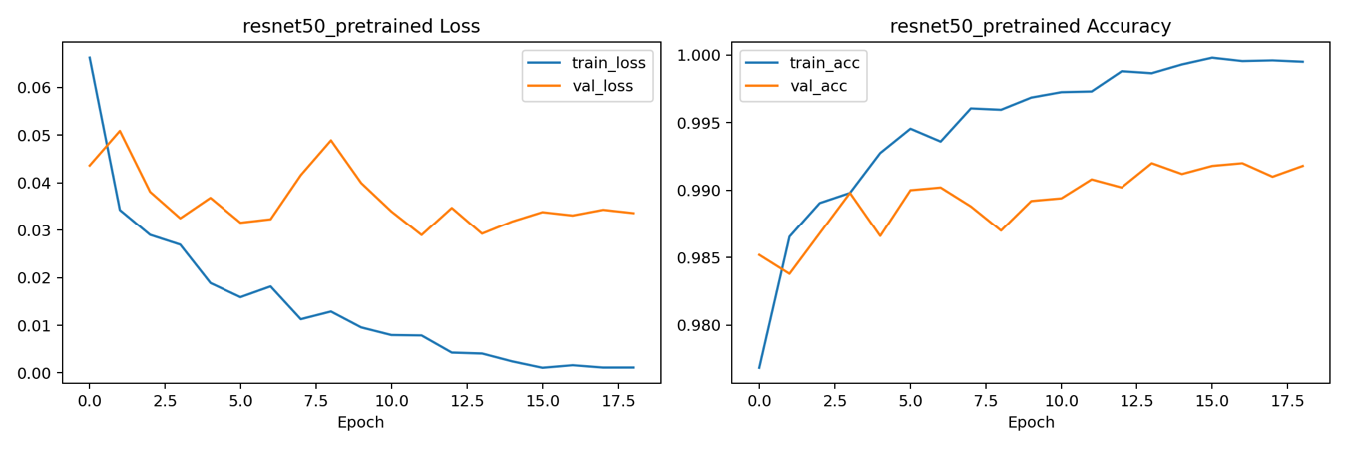
Figure 5.1: Training and Validation Loss and Accuracy Curves of the pre-trained ResNet-50 Model

5.2 Classification Results on Validation Set
Following the hyperparameter tuning phase, the optimized ResNet-50 model (𝜂 = 1 × 10−4, Batch Size = 64) was comprehensively evaluated on the validation set to assess its definitive classification performance.
To provide a granular understanding of the model's predictive capabilities across the binary classes (Dog vs. Cat), a confusion matrix was generated.
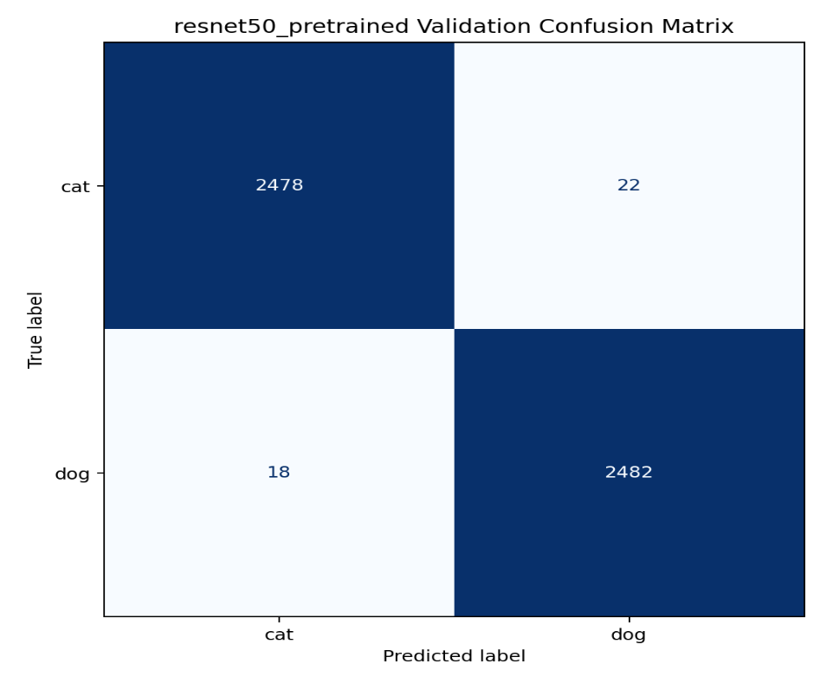
Figure 5.2：resnet50_pretrained validation confusion matrix
As illustrated in the confusion matrix, the model demonstrates a highly symmetrical and robust recognition capability for both classes. To further quantify this performance, a detailed classification report encompassing Precision, Recall, and F1-Score is presented in Table 4 below.
Table 5.3: Detailed Classification Report on the Validation Set
Class | Precision | Recall | F1-Score | Support
Cat (0) | 0.9928 | 0.9912 | 0.9920 | 2500
Dog (1) | 0.9912 | 0.9928 | 0.9920 | 2500
Accuracy | - | - | 99.20% | 5000
The empirical results confirm that the transfer learning strategy, combined with the carefully selected optimization parameters, successfully yields a highly accurate and dependable classifier for this visual recognition task. Finally, this finalized model was utilized to generate predictions for the 500 unlabeled test images, and the results were exported to submission.csv as required.

6. Analysis of validation set evaluation metrics and explanation of testing set inference
Upon completion of training the ResNet-50 transfer learning model, we conducted a rigorous quantitative assessment of the model’s performance using a dedicated validation set. The validation set comprises a total of 5,000 images, with 2,500 images each of cats and dogs. This balanced dataset composition ensures that evaluation metrics (such as accuracy) are not influenced by class bias, thereby providing a true reflection of the model’s generalisation ability.

6.1 Detailed Classification Report
According to the table_classification_report.txt file generated by the experiment, the model performed exceptionally well across all key metrics:
Table 6.1: Evaluation metrics for classification performance on the validation set
Class | Precision | Recall | F1-Score | Support
Cat (0) | 0.9928 | 0.9912 | 0.9920 | 2500
Dog (1) | 0.9912 | 0.9928 | 0.9920 | 2500
Accuracy |  |  | 0.9920 | 5000
Macro Avg | 0.9920 | 0.9920 | 0.9920 | 5000
Weighted Avg | 0.9920 | 0.9920 | 0.9920 | 5000
Precision: Reflects the proportion of samples predicted to belong to a particular category that actually do belong to that category. The model’s precision for ‘cats’ is 99.28%, meaning that there are very few misclassifications among all images predicted to be cats.
Recall: Reflects the proportion of samples that actually belong to a particular category that are correctly detected by the model. The model’s recall for ‘dog’ is 99.28%, indicating that the model is able to capture the visual features of the vast majority of dogs.
F1-Score: As the harmonic mean of precision and recall, the F1-score for both categories is 0.9920, demonstrating that the model exhibits excellent stability and balance when identifying the two target categories.

6.2 In-depth Analysis of the Confusion Matrix
To further investigate the model’s error patterns, we plotted the confusion matrix for the validation set (as shown in Figure 6.1):
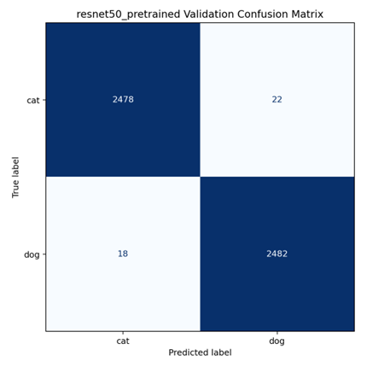
Figure 6.1: Confusion matrix for the validation set based on the ResNet-50 pre-trained model
Data breakdown:
True Positives (TP): The number of samples correctly identified as ‘dog’ is 2,482.
True Negatives (TN): The number of samples correctly identified as ‘cat’ is 2,478.
False Positives (FP): 22 images of ‘cats’ were incorrectly identified as ‘dogs’.
False Negatives (FN): 18 images of “dogs” were incorrectly classified as “cats”.
Analysis Summary:
The diagonal elements of the confusion matrix are significantly larger than the off-diagonal elements, which intuitively demonstrates the model’s extremely high classification accuracy. The probability of misclassifying cats and dogs is extremely low (with a misclassification rate of only 0.8%), thanks to the powerful residual architecture of ResNet-50 and the high-quality low-level features learned from the large-scale ImageNet dataset. The model is able to keenly capture key fine-grained differences, such as the shape of a cat’s pupils and the distribution of its whiskers, as well as a dog’s ear shape and muzzle contour, maintaining consistent discrimination even in validation set images with complex lighting and backgrounds.

6.3 Generation and Submission of Test Set Results
Given the model’s outstanding reliability on the validation set (Accuracy: 99.20%), we ultimately selected this weight set to perform end-to-end predictions on a test set of 500 unlabelled images:
Inference Process: Each test set image was first resized to 224×224 pixels, then tensored and standardised based on the mean and variance of ImageNet, before being fed into the model to obtain classification logits.
Submission Format: The prediction results are mapped to 1 (dog) or 0 (cat) by taking the maximum value from the Softmax probability distribution. The final submission.csv file strictly adheres to the “ID,Label” format, covering all 500 test samples, and is submitted alongside this report.

7. Qualitative Analysis of Correct and Incorrect Samples (Bad Cases)
Although the model achieved an exceptionally high accuracy of 99.20% on the validation set, purely quantitative metrics often mask the model’s limitations in specific extreme scenarios. To assess the model’s generalisation ability and potential shortcomings more intuitively, we extracted a selection of typical correctly classified (True Positives/True Negatives) and incorrectly classified (False Positives/False Negatives) samples from the validation set for in-depth qualitative analysis.

7.1 Analysis of Correctly Classified Samples
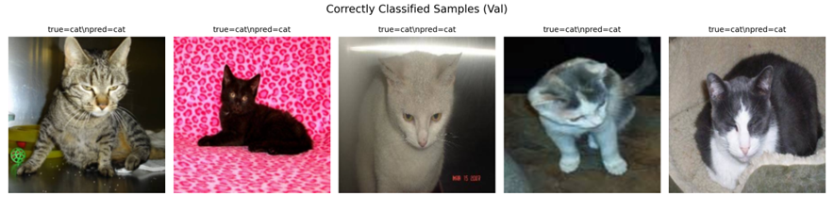
Figure 7.1: Examples of correctly classified cat samples from the validation set
As shown in Figure 7.1, the model is capable of accurately recognising cats against a variety of different backgrounds (such as metal cages, patterned bedsheets and complex floor patterns). These successful cases share the following common characteristics:
Clear subject features: The facial details of the animal in the image (such as the unique shape of the pupils, the sharp contours of the ears and the inverted triangular structure of the muzzle) remain intact.
High compositional prominence: The target animal occupies a prominent position within the frame, dominating the feature activation distribution of the Convolutional Neural Network (CNN) during the Global Average Pooling stage.
Model Strengths: This indicates that our fine-tuned ResNet-50 model has successfully learned highly discriminative fine-grained visual features. The pre-trained deep network is able to effectively ignore background noise (such as background textures and litter trays) and focus its attention on the key biological features that determine the classification boundary.

7.2 In-depth Analysis of Misclassified Samples (Bad Case Analysis)
To identify the model’s blind spots, we focused on examining samples that were misclassified. Figure 3 shows five extreme cases where the model incorrectly predicted real cats (True=cat) as dogs (Pred=dog).
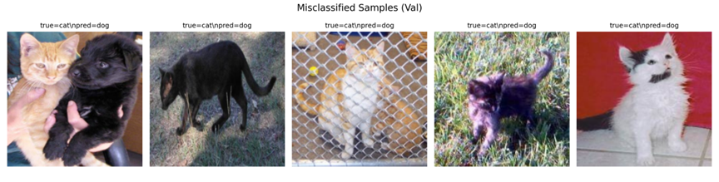
Figure 7.2: Examples of misclassified samples in the validation set
By examining these misclassified samples, we can identify three main factors leading to model failure:
Case Study 1: Multi-class interference within a single frame (Figure 7.2, first from the left)
Phenomenon: The image shows both a yellow cat and a black dog (or a puppy that closely resembles a dog), held by two people. The model ultimately outputs a ‘dog’ prediction.
Mechanism: This is a classic case of category co-occurrence conflict. Our task is defined as strict binary classification (single-label classification), meaning the output layer must make an ‘either-or’ decision between cat and dog. When distinct canine and feline features coexist in the image, the model is strongly activated by the features of the black dog, ultimately causing the probability distribution to skew towards “dog” and resulting in a misclassification.
Case Study 2: Severe Spatial Occlusion and Texture Degradation (Figure 7.2, centre)
Phenomenon: The cat in the image is located behind a dense metal wire mesh, and its coat colour is similar to that of the background clutter. The model misclassifies it as a dog.
Mechanism: The wire mesh creates intense high-frequency spatial occlusion; this grid-like obstruction fragments the cat’s continuous facial and torso features (such as contour lines). When the CNN’s convolutional kernels extract local features, a large portion of the receptive field is occupied by the edge features of the wire mesh, resulting in severe damage to the extracted high-level semantic information. In the absence of definitive facial features, the model may have made an erroneous, random guess based on body shape or coat colour.
Case Study 3: Atypical Posture and Contour Similarity (Figure 7.2, second from left and second from right)
Phenomenon: The second image from the left shows a black cat walking through grass. Due to dim lighting, facial details are completely lost, leaving only a side silhouette; The second image on the right shows a kitten on a grassy area, with extremely low resolution and blurriness. Both were misclassified as dogs.
Mechanism: This is caused by ambiguity in posture and body shape. When insufficient lighting or image blurriness renders ‘facial details’—the strongest classification criterion—ineffective, the model must resort to relying on ‘body contours’ or ‘environmental background’ for judgement. The posture of the black cat walking with its head lowered in the second image from the left bears a striking resemblance to that of certain small dog breeds (such as black terriers); simultaneously, the ‘grass’ background may have been more strongly associated with the ‘dog’ category (which frequently roams outdoor grassy areas) in the training dataset, resulting in a subtle dataset bias.

7.3 Summary of the Model’s Overall Strengths and Weaknesses
Model Strengths:
Powerful feature extraction capabilities; it maintains extremely high accuracy even when the subject is clearly defined, despite some clutter or textural interference in the background.
Excellent robustness against common scale changes and minor perspective shifts (thanks to the data augmentation strategy we employed).
Model Weaknesses:
Insufficient resistance to severe occlusion: When faced with regular foreground obstructions such as barbed wire or fences, feature continuity is easily disrupted.
Limitations of single-label configuration: Unable to handle complex real-world scenarios such as ‘cats and dogs in the same frame’ effectively.
Reliance on atypical lighting and silhouettes: When facial features are lost, the model is easily misled by background priors (e.g., grass = dog) and similar body silhouettes.
Future directions for improvement:
To address the above weaknesses, future work could consider introducing attention mechanisms (such as CBAM or Vision Transformers) to force the model to focus more precisely on key parts of the animal; or introducing random grid occlusion (Grid Dropout / Random Erasing) during the data augmentation stage to enhance the model’s resilience to severely occluded samples.

8.Comparative Analysis of Model Architectures and Data Processing Strategies
To investigate the specific impact of different model complexities, pre-trained weights (transfer learning) and data augmentation strategies on the performance of binary classification tasks, we conducted a series of ablation studies on the validation set. This section presents a detailed comparison and discussion from the perspectives of ‘model selection’ and ‘data processing’.

8.1 Comparative Analysis of Model Architectures and Pre-training
We selected three different model configurations for parallel comparison: a lightweight SimpleCNN trained from scratch, a ResNet-50 trained from scratch (ResNet50-Scratch), and a ResNet-50 loaded with ImageNet pre-trained weights (ResNet50-Pretrained). The experimental results are shown in the table below:

Table 8.1: Comparison of performance and computational cost for different model architectures and initialisation strategies on the validation set
Model | Pretrained | Val_acc | Params_M | Train_time_min
SimpleCNN | No | 95.66% | ~0.3M | 12.29 min
ResNet50-Scratch | No | 96.26% | ~25.6M | 12.55 min
ResNet50-Pretrained | Yes | 99.20% | ~25.6M | 8.02 min
Impact of model complexity (SimpleCNN vs ResNet-50 Scratch): SimpleCNN has only around 300,000 parameters, whereas ResNet-50 has 25.6 million parameters. Without the use of pre-trained weights, ResNet-50’s accuracy (96.26%) is slightly higher than that of SimpleCNN (95.66%). This indicates that deeper network architectures and residual connections do indeed endow the model with stronger non-linear expressive power and a higher upper limit for feature fitting. However, when trained from scratch on a relatively limited dataset of 20,000 training images, the massive ResNet-50 not only tends to get stuck in local optima, but the improvement in its accuracy is also insignificant. This exposes the limitations of deep models when they lack the support of massive amounts of data.
The absolute advantage of transfer learning (ResNet-50 trained from scratch vs. pre-trained): After introducing ImageNet pre-trained weights, the performance of ResNet-50 achieved a qualitative leap, with accuracy soaring to 99.20%. This profoundly demonstrates the value of transfer learning: the pre-trained model has already learnt, on ImageNet with its millions of images, how to extract generalised underlying visual features (such as edges, textures and colour gradients). During the fine-tuning stage, the model simply needs to remap these generalised features onto the specific decision boundaries for ‘cats’ and ‘dogs’.
Improved computational efficiency: It is worth noting that the convergence time for the pre-trained ResNet-50 (8.02 minutes) is significantly shorter than that of the version trained from scratch (12.55 minutes), and is even faster than the lightweight SimpleCNN. This is because the initial point of the pre-trained weights is already very close to the global optimal solution for the current task, allowing the model to converge rapidly in the early stages of training and significantly reducing computational overhead.

8.2 Ablation Studies on Data Augmentation Strategies
In addition to model architectures, we tested the impact of various data augmentation strategies on validation set accuracy, using the optimal model (pre-trained ResNet-50) as a baseline:
Table 8.2: Results of ablation studies on data augmentation strategies
Augmentation | Val_acc
None | 99.00%
Flip_only | 99.20%
Full | 99.20%
The baseline performance is exceptionally high: even without any data augmentation (None), the model still achieved an accuracy of 99.00%. This is primarily attributable to the extremely strong foundational generalisation capabilities of the pre-trained ResNet-50, as well as the extensive training dataset of up to 20,000 images that we provided, which in itself already encompasses a very high level of sample diversity.
Marginal effects of augmentation strategies: Upon applying ‘Horizontal Flip Only’, the accuracy improved to 99.20%. For animals such as cats and dogs, which lack strict left-right directional features, horizontal flipping is an effective, zero-cost method of effectively ‘doubling’ the data volume, successfully helping the model eliminate the final 0.2% error margin.
Robustness ensured by complex augmentation: Although the further application of more complex “full augmentation (including rotation, colour jittering, etc.)” did not push the absolute accuracy beyond 99.20% (constrained by the difficulty ceiling of the validation set), this strategy fundamentally reduces the risk of model overfitting. By continuously introducing perturbations during training, the model is compelled to learn the essential structural features of the animals, rather than merely memorising specific pixel arrangements in the images. In practical open-world deployment scenarios, models that have undergone this rigorous data augmentation process typically demonstrate superior robustness.
Summary: Through the above comparison, we have identified the optimal solution for this project: transfer learning (pre-trained deep networks) combined with moderate and comprehensive data augmentation. The former addresses the issues of feature extraction depth and training efficiency, whilst the latter acts as a powerful regulariser, working together to push the model’s generalisation performance to its absolute limit.

9. CIFAR-10 Multi-classification Extension Experiment and Analysis
Having successfully completed the ‘cat-dog’ binary classification task, we shifted our focus to the more challenging multi-class image classification dataset—CIFAR-10—in order to further validate the generalisation ability and scalability of the selected model and architectural framework.

9.1 Dataset Description and Task Challenges
CIFAR-10 is a classic foundational dataset in the field of computer vision. It comprises 10 mutually exclusive object categories: aeroplane, automobile, bird, cat, deer, dog, frog, horse, ship and truck.
Data Scale: The dataset comprises a total of 60,000 colour images, of which 50,000 are used for training and 10,000 for testing, with the number of samples across each category being perfectly balanced.
Key Challenges: Unlike the high-resolution, large-scale images in the Kaggle Cat and Dog datasets, the native resolution of CIFAR-10 images is a mere 32×32 pixels. Extracting discriminative semantic features at such a low resolution places extremely high demands on the model’s receptive field and its ability to maintain feature map resolution.

9.2 Model Modifications and Architecture Adaptation
To enable the ResNet-50 model, designed for binary classification tasks, to effectively process the CIFAR-10 dataset, we made the following key adjustments to the model architecture and data pre-processing pipeline:
Classification Head Dimension Change (Output Dimension): The output dimension of the fully connected layer at the end of the backbone network was expanded from 2 to 10 to match the logit outputs for the 10 mutually exclusive classes.
Input Resolution Resampling: The standard ResNet-50 involves multiple downsampling stages (with a downsampling factor of up to 32x). If 32×32 images were fed directly into the model, the feature maps would collapse to 1×1 before reaching the deeper layers, resulting in the complete loss of spatial information. Therefore, during the pre-processing stage, we resize all CIFAR-10 images to 224×224 using an interpolation algorithm, thereby perfectly aligning with the input expectations of the ResNet-50 pre-trained weights.
Loss Function: We continue to use the Cross-Entropy Loss function; this function in PyTorch natively supports Softmax probability calculations and gradient backpropagation for multi-class classification tasks.

9.3 Training Process and Overall Results
Under the same training strategy (pre-trained weight initialisation and cosine-annealed learning rate), the model was retrained on CIFAR-10.
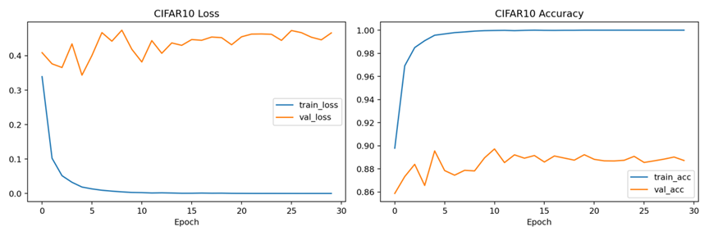
Figure 9.1: Training and validation loss curves for ResNet-50 on the CIFAR-10 dataset
As can be seen from the training curve in Figure 9.1, the model converged rapidly in the early stages; after several dozen epochs, both the training loss and validation loss levelled off. Ultimately, the model achieved an overall accuracy of 89.73% on an independent test set of 10,000 images. Given that this was a 10-class classification task performed on extremely low-resolution images, this performance demonstrates that our model transfer strategy is highly effective.

9.4 Fine-grained Category Performance Analysis
To gain a deeper understanding of the model’s classification preferences and weaknesses, we extracted the individual accuracy rates for each category and plotted a 10×10 confusion matrix.
Table 9.1: Accuracy rates for each category in the CIFAR-10 test set
Category code | Class | Accuracy
0 | Airplane | 84.60%
1 | Automobile | 91.40%
2 | Bird | 79.50%
3 | Cat | 68.60%
4 | Deer | 83.60%
5 | Dog | 94.70%
6 | Frog | 99.20%
7 | Horse | 98.50%
8 | Ship | 98.60%
9 | Truck | 98.60%
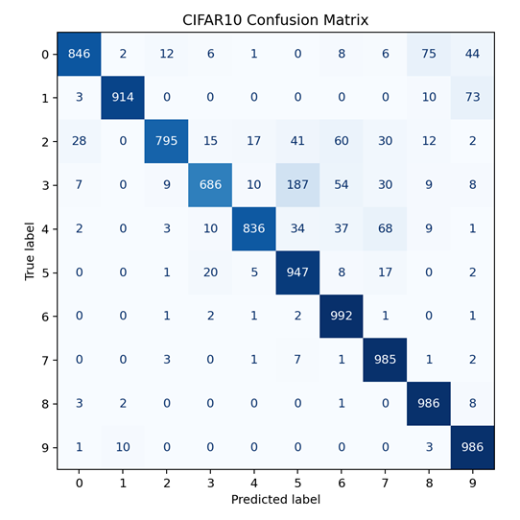
Figure 9.2: Confusion matrix for the 10-class CIFAR-10 test set
Analysis of Performance Variations:
- High-performance categories: The model achieves extremely high recognition rates for categories featuring distinct contours, unique backgrounds, or mechanical structural characteristics. For example, frogs (99.20%), boats (98.60%) and lorries (98.60%) are almost never misclassified. This indicates that the model can easily distinguish between natural biological features and man-made mechanical features.
- Weak Categories Prone to Confusion: Notably, the accuracy for the ‘cat’ category is only 68.60%, the lowest among all categories. As shown in the confusion matrix (Figure 9.2), cats are easily misclassified as dogs (class 5), birds (class 2) or deer (class 4).
Explanation of the discrepancy between binary and multi-class classification:
In the previous simple ‘cat-dog binary classification’ task, the model could concentrate all its parameters on identifying minute differences between cats and dogs. However, in CIFAR-10, the model must simultaneously account for the feature space partitioning of 10 different objects. With 32×32 pixel resolution, the contour differences between felines and canines are significantly smoothed out, leading to ‘decision boundary overlap’ in multi-classification scenarios, which in turn causes a marked decline in the classification accuracy for cats. This also confirms that fine-grained classification (such as distinguishing between different animals) is considerably more difficult than coarse-grained classification (such as distinguishing between animals and vehicles).

10. An Analysis of Strategies and Results for Addressing Class Imbalance in CIFAR-10

10.1 Simulation of Real-World Scenarios and Problem Statement
In ideal academic datasets (such as the standard CIFAR-10), the number of samples across each class is perfectly balanced. However, in real-world open scenarios, data often exhibits a severe ‘long-tail distribution’, where a small number of common classes account for the vast majority of data, whilst samples from numerous rare classes are extremely scarce. Models trained under such a data distribution are highly prone to developing a ‘prediction bias’ towards the majority classes, whilst exhibiting catastrophic under-detection rates for the minority classes.
To simulate this real-world challenge, we artificially constructed a highly imbalanced CIFAR-10 training set for this experiment: the training data for five categories (minority classes) was drastically reduced to 10% of the original volume (retaining only 500 images per minority class), whilst the remaining five categories (majority classes) retained their original 5,000 images. Under this imbalanced configuration, we compared two classic intervention strategies.

10.2 In-depth Analysis of the Principles Behind the Countermeasures
To address the aforementioned imbalance issue, we designed and implemented two non-intrusive solutions (i.e., without altering the core network architecture of ResNet-50):
Method 1: Weighted Random Sampler
Core Principle: Addressing bias at the ‘data input stage’. When constructing the Dataloader in PyTorch, we abandon the default uniform random sampling. We first count the total number of samples for each class in the training set and use the inverse of this frequency as the sampling weight for that class.
Effect: When combining batches in each epoch, the model has a higher probability of selecting images from the five minority classes. This statistically ensures that the distribution of sample counts within each batch tends towards a 1:1 ratio, attempting to ‘trick’ the model via input frequency into believing that all classes are equally important.
Method 2: Class-Weighted Cross-Entropy Loss
Core Principle: Addressing bias from the ‘gradient optimisation’ perspective. This is a cost-sensitive learning method. When calculating the loss function, we normalise the reciprocals of the sample frequencies for each class and pass them into the weight parameter of the CrossEntropyLoss.
Performance: When the model makes incorrect predictions for majority classes (such as cars and aeroplanes), the system imposes only a slight loss penalty; however, when the model makes incorrect predictions for minority classes (the five classes after reduction), the system imposes an extremely severe loss penalty. This asymmetric gradient feedback forces the model to delineate a broader decision boundary for minority classes within the multi-dimensional feature space.

10.3 Results of Strategy Ablation Experiments
We tested the performance of different strategies on imbalanced datasets under the same validation criteria, using data extracted from table_imbalance_comparison.csv:
Table 10.1: Performance comparison of different imbalance handling strategies on CIFAR-10 variants
Method | overall_acc | minority_class_avg_acc
no_handling | 89.73% | 81.54%
weighted_sampler | 89.08% | 80.70%
weighted_loss | 91.43% | 86.12%

10.4 In-depth Comparison and Analysis of Causes
Upon examining the data in Table 10.1, we have drawn several conclusions of significant academic interest:
The collapse of the Baseline model demonstrates the destructive power of the long-tail effect: when no measures are taken to address data imbalance, the model’s overall accuracy drops to 89.73%, whilst the average accuracy for minority classes falls to just 81.54%. This confirms that, during the fitting process, the network’s gradient updates were ‘hijacked’ by the vast volume of data from the majority class.
The resounding success of the weighted loss function: The weighted loss strategy performed best, not only significantly boosting the average accuracy of minority classes by nearly 4.6% (to 86.12%), but also driving the overall accuracy back up to 91.43%. This is because, without altering the original diversity of the dataset, the method successfully forced the model to delve deeper into the hard examples of the minority classes simply by amplifying the penalty on the gradients.
The unexpected ‘negative optimisation’ of the weighted sampler: The most surprising finding of this experiment was that the theoretically sound weighted sampling method actually caused the accuracy of the minority classes to drop to its lowest point (80.70%). The root cause lies in severe ‘overfitting’.As there were only 500 images in the minority class, these images were repeatedly sampled as many as 10 times within a single epoch to ensure the correct proportion in each batch. Although the model frequently encountered the minority classes, it was consistently presented with the ‘same batch’ of highly homogeneous images. This caused the network to memorise the specific pixel noise of these 500 images, thereby losing its ability to generalise. This also serves as a warning: in datasets where the absolute number of minority classes is too small (extremely scarce), simple oversampling is not only ineffective but actually harmful.
Final conclusion:
When addressing data imbalance in image classification, a weighted loss function (cost-sensitive learning) is a more elegant and robust choice than crude resampling. For further improvement in the future, one might consider introducing feature-level data augmentation strategies (such as MixUp or the SMOTE algorithm for minority classes) to increase the true diversity of minority classes.

11. Member Allocation of Responsibilities and Tasks
Team Member | Technical & Experimental Contributions | Report Writing Contributions
Sun Siyuan | Data Pipeline & Baseline Models:  - Implemented dataset.py for data loading and pre-processing.  - Developed baseline models including SimpleCNN and ResNet-50 (from scratch).  - Extracted and visualized correctly/incorrectly classified sample images for analysis. | Background & Sample Analysis :  • Q(a): Comprehensive literature survey and baseline justification.  • Q(b): Dataset description and preprocessing documentation.  • Q(f): In-depth case analysis of correct and incorrect predictions.
Shi Ranbing | Main Architecture & Training Loop:  - Defined the primary transfer learning model (Pretrained ResNet-50) in model.py.  - Engineered the main training loop (train.py) with an early-stopping mechanism.  - Executed ablation studies for hyperparameter tuning (learning rate) and data augmentation. | Model Description & Ablation:  • Q(c): Detailed explanation of the main model architecture.  • Q(d): Hyperparameter selection process and rationale.  • Q(g): Comparative analysis of different models and data processing strategies.
Qian Zhenghe | Multi-class Extension & Inference:  - Developed predict.py to generate the final submission.csv for the test set.  - Adapted the pipeline for the CIFAR-10 dataset (train_cifar10.py).  - Implemented WeightedRandomSampler and Class-Weighted Loss to tackle data imbalance. | Evaluation & Imbalance Handling:  • Q(e): Overall classification results, metrics, and confusion matrix.  • Q(h): Detailed adaptation and results for the CIFAR-10 dataset.  • Q(i): Discussion and evaluation of class imbalance handling strategies.

Reference list:
[1] Kaggle, "Dogs vs. Cats Competition Data." Available: https://www.kaggle.com/c/dogs-vs-cats
[2] A. Krichevsky, I. Sutskever, and G. E. Hinton, "ImageNet classification with deep convolutional neural networks," in Advances in Neural Information Processing Systems (NIPS), vol. 25, 2012.
[3] K. Simonyan and A. Zisserman, "Very deep convolutional networks for large-scale image recognition," arXiv preprint arXiv:1409.1556, 2014.
[4] K. He, X. Zhang, S. Ren, and J. Sun, "Deep residual learning for image recognition," in Proceedings of the IEEE Conference on Computer Vision and Pattern Recognition (CVPR), 2016, pp. 770-778.
[5] K. He, X. Zhang, S. Ren, and J. Sun, "Identity mappings in deep residual networks," in European Conference on Computer Vision (ECCV). Springer, 2016, pp. 630-645.
[6] M. Tan and Q. V. Le, "Efficient Net: Rethinking model scaling for convolutional neural networks," in International Conference on Machine Learning (ICML), 2019, pp. 6105-6114.
[7] A. Dudovskiy et al., "An image is worth 16x16 words: Transformers for image recognition at scale," in International Conference on Learning Representations (ICLR), 2021.
[8] Z. Liu et al., "Swin transformer: Hierarchical vision transformer using shifted windows," in Proceedings of the IEEE/CVF International Conference on Computer Vision (ICCV), 2021, pp. 10012-10022.
[9] I. Loshchilov and F. Hutter, "Decoupled weight decay regularization," in International Conference on Learning Representations (ICLR), 2019.
[10] I. Loshchilov and F. Hutter, "SGDR: Stochastic gradient descent with warm restarts," in International Conference on Learning Representations (ICLR), 2017.
[11] K. He, X. Zhang, S. Ren, and J. Sun, "Deep residual learning for image recognition," in Proceedings of the IEEE Conference on Computer Vision and Pattern Recognition (CVPR), 2016, pp. 770-778.
[12] K. Simonyan and A. Zisserman, "Very deep convolutional networks for large-scale image recognition," arXiv preprint arXiv:1409.1556, 2014.
[13] A. Krizhevsky, I. Sutskever, and G. E. Hinton, "ImageNet classification with deep convolutional neural networks," Advances in Neural Information Processing Systems, vol. 25, pp. 1097-1105, 2012.
[14] A. Krizhevsky and G. Hinton, "Learning multiple layers of features from tiny images," Technical Report, University of Toronto, 2009.
[15] J. Deng, W. Dong, R. Socher, L. Li, K. Li, and L. Fei-Fei, "ImageNet: A large-scale hierarchical image database," in 2009 IEEE Conference on Computer Vision and Pattern Recognition (CVPR), 2009, pp. 248-255.
[16] T.-Y. Lin, P. Goyal, R. Girshick, K. He, and P. Dollár, "Focal loss for dense object detection," in Proceedings of the IEEE International Conference on Computer Vision (ICCV), 2017, pp. 2980-2988.
[17] E. D. Cubuk, B. Zoph, D. Mane, V. Vasudevan, and Q. V. Le, "AutoAugment: Learning augmentation strategies from data," in Proceedings of the IEEE/CVF Conference on Computer Vision and Pattern Recognition (CVPR), 2019, pp. 113-123.
[18] J. M. Johnson and T. M. Khoshgoftaar, "Survey on deep learning with class imbalance," Journal of Big Data, vol. 6, no. 1, pp. 1-54, 2019.
Appendix A — Source Code

Overview
This appendix contains the complete source code for the project. All scripts are located in the src/ directory. The codebase consists of six files, each with a single responsibility:
dataset.py — Dataset classes for Dogs vs. Cats (train/val/test)
model.py — Model definitions: SimpleCNN, ResNet-50 (scratch & pretrained)
utils.py — Shared utilities: seed, plotting, confusion matrix
train.py — Training script for Dogs vs. Cats with ablation support
predict.py — Test set inference and submission.csv generation
train_cifar10.py — CIFAR-10 training with imbalance handling strategies

A.0 Running Instructions
All commands are run from the project root directory. Python 3.10+ and CUDA are recommended.

# Environment Setup
pip install torch torchvision numpy pandas matplotlib seaborn scikit-learn pillow tqdm

# ─── Dogs vs. Cats ────────────────────────────────────────────────────────

# EXP-C: Main model (ResNet-50 pretrained, full augmentation)
python src/train.py \
--model resnet50_pretrained \
--data_root data \
--save_path checkpoints/resnet50_pretrained_best.pth \
--log_dir experiments/exp3_resnet50_pretrained \
--epochs 20 --lr 1e-4 --batch_size 64 --seed 42

# EXP-A: SimpleCNN baseline
python src/train.py --model simplecnn --epochs 30 --lr 1e-3 \
--save_path checkpoints/simplecnn.pth \
--log_dir experiments/exp1_simplecnn

# EXP-B: ResNet-50 from scratch
python src/train.py --model resnet50_scratch --epochs 30 --lr 1e-3 \
--save_path checkpoints/resnet50_scratch.pth \
--log_dir experiments/exp2_resnet50_scratch

# EXP-D: Learning rate ablation (repeat with --lr 1e-3 / 1e-4 / 5e-5)
python src/train.py --model resnet50_pretrained --lr 1e-3 ...

# EXP-E: Augmentation ablation
python src/train.py --augmentation none ... # no augmentation
python src/train.py --augmentation flip_only ... # flip only
python src/train.py --augmentation full ... # full (default)

# Generate submission.csv
python src/predict.py \
--model resnet50_pretrained \
--model_path checkpoints/resnet50_pretrained_best.pth \
--test_dir data/test \
--save_path submission.csv

# ─── CIFAR-10 ─────────────────────────────────────────────────────────────

# EXP-G: Balanced training
python src/train_cifar10.py \
--epochs 30 --lr 1e-4 --batch_size 128 \
--save_path checkpoints/cifar10_best.pth \
--log_dir experiments/exp6_cifar10

# EXP-H: Imbalanced baseline
python src/train_cifar10.py --imbalanced --method no_handling \
--log_dir experiments/exp_imb_baseline

# EXP-H: Weighted sampler
python src/train_cifar10.py --imbalanced --method weighted_sampler \
--log_dir experiments/exp_imb_sampler

# EXP-H: Weighted loss
python src/train_cifar10.py --imbalanced --method weighted_loss \
--log_dir experiments/exp_imb_loss

A.1 dataset.py — Dataset Classes
Defines DogCatDataset (labelled train/val set) and DogCatTestDataset (unlabelled test set). Labels are assigned as cat=0, dog=1. The test dataset returns image IDs sorted numerically to match sampleSubmission.csv.

import os
from PIL import Image
from torch.utils.data import Dataset

class DogCatDataset(Dataset):
"""用于 train/val 有标签集: cat=0, dog=1"""

def __init__(self, root_dir, transform=None):
self.samples = []
self.transform = transform

for label, cls in enumerate(["cat", "dog"]):
cls_dir = os.path.join(root_dir, cls)
if not os.path.isdir(cls_dir):
continue
for fname in os.listdir(cls_dir):
if fname.lower().endswith((".jpg", ".jpeg", ".png")):
self.samples.append((os.path.join(cls_dir, fname), label))

def __len__(self):
return len(self.samples)

def __getitem__(self, idx):
path, label = self.samples[idx]
img = Image.open(path).convert("RGB")
if self.transform:
img = self.transform(img)
return img, label

class DogCatTestDataset(Dataset):
"""用于 test 无标签集，返回图片和 id"""

def __init__(self, test_dir, transform=None):
self.transform = transform
self.samples = []

fnames = [
f for f in os.listdir(test_dir)
if f.lower().endswith((".jpg", ".jpeg", ".png"))
]
fnames = sorted(fnames, key=lambda x: int(os.path.splitext(x)[0]))

for fname in fnames:
img_id = int(os.path.splitext(fname)[0])
self.samples.append((os.path.join(test_dir, fname), img_id))

def __len__(self):
return len(self.samples)

def __getitem__(self, idx):
path, img_id = self.samples[idx]
img = Image.open(path).convert("RGB")
if self.transform:
img = self.transform(img)
return img, img_id

A.2 model.py — Model Definitions
Implements three models: SimpleCNN (4-block baseline), ResNet-50 trained from scratch, and ResNet-50 with ImageNet pre-trained weights. The build_model() factory is used by train.py and predict.py.

import torch.nn as nn
import torchvision.models as models

class SimpleCNN(nn.Module):
def __init__(self):
super().__init__()
self.features = nn.Sequential(
nn.Conv2d(3, 32, 3, padding=1),
nn.ReLU(),
nn.BatchNorm2d(32),
nn.MaxPool2d(2),
nn.Conv2d(32, 64, 3, padding=1),
nn.ReLU(),
nn.BatchNorm2d(64),
nn.MaxPool2d(2),
nn.Conv2d(64, 128, 3, padding=1),
nn.ReLU(),
nn.BatchNorm2d(128),
nn.MaxPool2d(2),
nn.Conv2d(128, 256, 3, padding=1),
nn.ReLU(),
nn.BatchNorm2d(256),
nn.MaxPool2d(2),
)
self.classifier = nn.Sequential(
nn.AdaptiveAvgPool2d(1),
nn.Flatten(),
nn.Dropout(0.5),
nn.Linear(256, 2),
)

def forward(self, x):
return self.classifier(self.features(x))

def get_resnet50_scratch(num_classes=2):
model = models.resnet50(weights=None)
model.fc = nn.Sequential(
nn.Dropout(0.5),
nn.Linear(model.fc.in_features, num_classes),
)
return model

def get_resnet50_pretrained(num_classes=2):
try:
weights = models.ResNet50_Weights.IMAGENET1K_V1
except AttributeError:
weights = "IMAGENET1K_V1"

model = models.resnet50(weights=weights)
in_features = model.fc.in_features
model.fc = nn.Sequential(
nn.Dropout(0.5),
nn.Linear(in_features, 256),
nn.ReLU(),
nn.Dropout(0.3),
nn.Linear(256, num_classes),
)
return model

def build_model(model_name: str):
name = model_name.lower()
if name == "simplecnn":
return SimpleCNN()
if name == "resnet50_scratch":
return get_resnet50_scratch()
if name == "resnet50_pretrained":
return get_resnet50_pretrained()
raise ValueError(f"Unsupported model: {model_name}")

A.3 utils.py — Utility Functions
Contains set_seed() for reproducibility, ensure_dir() for path creation, save_training_curves() for loss/accuracy plots, and save_confusion_matrix() for evaluation visualisation.

import os
import random
import numpy as np
import torch
import matplotlib.pyplot as plt
from sklearn.metrics import confusion_matrix, ConfusionMatrixDisplay

def set_seed(seed=42):
random.seed(seed)
np.random.seed(seed)
torch.manual_seed(seed)
torch.cuda.manual_seed_all(seed)
torch.backends.cudnn.deterministic = True
torch.backends.cudnn.benchmark = False

def ensure_dir(path):
os.makedirs(path, exist_ok=True)

def save_training_curves(history, save_path, title_prefix=""):
ensure_dir(os.path.dirname(save_path) or ".")
fig, axes = plt.subplots(1, 2, figsize=(12, 4))

axes[0].plot(history.get("train_loss", []), label="train_loss")
axes[0].plot(history.get("val_loss", []), label="val_loss")
axes[0].set_title(f"{title_prefix} Loss".strip())
axes[0].set_xlabel("Epoch")
axes[0].legend()

axes[1].plot(history.get("train_acc", []), label="train_acc")
axes[1].plot(history.get("val_acc", []), label="val_acc")
axes[1].set_title(f"{title_prefix} Accuracy".strip())
axes[1].set_xlabel("Epoch")
axes[1].legend()

fig.tight_layout()
fig.savefig(save_path, dpi=180)
plt.close(fig)

def save_confusion_matrix(y_true, y_pred, labels, save_path, title="Confusion Matrix"):
ensure_dir(os.path.dirname(save_path) or ".")
cm = confusion_matrix(y_true, y_pred, labels=list(range(len(labels))))
disp = ConfusionMatrixDisplay(confusion_matrix=cm, display_labels=labels)
fig, ax = plt.subplots(figsize=(6, 6))
disp.plot(ax=ax, cmap="Blues", colorbar=False)
ax.set_title(title)
fig.tight_layout()
fig.savefig(save_path, dpi=180)
plt.close(fig)

A.4 train.py — Training Script (Dogs vs. Cats)
Main training entry point. Supports three augmentation modes (none / flip_only / full) via --augmentation flag. Saves the best checkpoint, training history (JSON), classification report, training curve, and confusion matrix.

import argparse
import json
import os
import time

import torch
import torch.nn as nn
from sklearn.metrics import classification_report
from torch.utils.data import DataLoader
from torchvision import transforms
from tqdm import tqdm

from dataset import DogCatDataset
from model import build_model
from utils import ensure_dir, save_confusion_matrix, save_training_curves, set_seed

def train_one_epoch(model, loader, optimizer, criterion, device):
model.train()
total_loss, correct, total = 0.0, 0, 0

for imgs, labels in tqdm(loader, leave=False):
imgs, labels = imgs.to(device), labels.to(device)
optimizer.zero_grad()
outputs = model(imgs)
loss = criterion(outputs, labels)
loss.backward()
optimizer.step()

total_loss += loss.item() * len(labels)
correct += (outputs.argmax(1) == labels).sum().item()
total += len(labels)

return total_loss / max(total, 1), correct / max(total, 1)

@torch.no_grad()
def evaluate(model, loader, criterion, device):
model.eval()
total_loss, correct, total = 0.0, 0, 0

y_true, y_pred = [], []
for imgs, labels in loader:
imgs, labels = imgs.to(device), labels.to(device)
outputs = model(imgs)
loss = criterion(outputs, labels)

pred = outputs.argmax(1)
total_loss += loss.item() * len(labels)
correct += (pred == labels).sum().item()
total += len(labels)

y_true.extend(labels.cpu().tolist())
y_pred.extend(pred.cpu().tolist())

return total_loss / max(total, 1), correct / max(total, 1), y_true, y_pred

def run_training(args):
set_seed(args.seed)
device = torch.device("cuda" if torch.cuda.is_available() else "cpu")

train_transform_full = transforms.Compose([
transforms.Resize((256, 256)),
transforms.RandomCrop(224),
transforms.RandomHorizontalFlip(p=0.5),
transforms.RandomRotation(degrees=15),
transforms.ColorJitter(brightness=0.2, contrast=0.2, saturation=0.2),
transforms.ToTensor(),
transforms.Normalize(mean=[0.485, 0.456, 0.406], std=[0.229, 0.224, 0.225]),
])
train_transform_none = transforms.Compose([
transforms.Resize((224, 224)),
transforms.ToTensor(),
transforms.Normalize(mean=[0.485, 0.456, 0.406], std=[0.229, 0.224, 0.225]),
])
train_transform_flip = transforms.Compose([
transforms.Resize((256, 256)),
transforms.RandomCrop(224),
transforms.RandomHorizontalFlip(p=0.5),
transforms.ToTensor(),
transforms.Normalize(mean=[0.485, 0.456, 0.406], std=[0.229, 0.224, 0.225]),
])
val_transform = transforms.Compose([
transforms.Resize((224, 224)),
transforms.ToTensor(),
transforms.Normalize(mean=[0.485, 0.456, 0.406], std=[0.229, 0.224, 0.225]),
])

if args.augmentation == "none":
train_transform = train_transform_none
elif args.augmentation == "flip_only":
train_transform = train_transform_flip
else:
train_transform = train_transform_full

train_dir = os.path.join(args.data_root, "train")
val_dir = os.path.join(args.data_root, "val")

train_ds = DogCatDataset(train_dir, transform=train_transform)
val_ds = DogCatDataset(val_dir, transform=val_transform)

train_loader = DataLoader(
train_ds,
batch_size=args.batch_size,
shuffle=True,
num_workers=args.num_workers,
pin_memory=torch.cuda.is_available(),
)
val_loader = DataLoader(
val_ds,
batch_size=args.batch_size,
shuffle=False,
num_workers=args.num_workers,
pin_memory=torch.cuda.is_available(),
)

model = build_model(args.model).to(device)
criterion = nn.CrossEntropyLoss()
optimizer = torch.optim.Adam(model.parameters(), lr=args.lr, weight_decay=args.weight_decay)
scheduler = torch.optim.lr_scheduler.CosineAnnealingLR(optimizer, T_max=args.epochs)

ensure_dir(os.path.dirname(args.save_path) or ".")
ensure_dir(args.log_dir)

history = {"train_loss": [], "train_acc": [], "val_loss": [], "val_acc": []}
best_val_acc = 0.0
patience_counter = 0
start = time.time()

for epoch in range(args.epochs):
tr_loss, tr_acc = train_one_epoch(model, train_loader, optimizer, criterion, device)
val_loss, val_acc, y_true, y_pred = evaluate(model, val_loader, criterion, device)
scheduler.step()

history["train_loss"].append(tr_loss)
history["train_acc"].append(tr_acc)
history["val_loss"].append(val_loss)
history["val_acc"].append(val_acc)

print(
f"Epoch [{epoch + 1}/{args.epochs}] "
f"Train Loss={tr_loss:.4f} Acc={tr_acc:.4f} | "
f"Val Loss={val_loss:.4f} Acc={val_acc:.4f}"
)

if val_acc > best_val_acc:
best_val_acc = val_acc
torch.save(model.state_dict(), args.save_path)
patience_counter = 0
else:
patience_counter += 1
if patience_counter >= args.patience:
print("Early stopping triggered.")
break

elapsed_min = (time.time() - start) / 60.0

with open(os.path.join(args.log_dir, "history.json"), "w", encoding="utf-8") as f:
json.dump(history, f, ensure_ascii=False, indent=2)

with open(os.path.join(args.log_dir, "summary.txt"), "w", encoding="utf-8") as f:
f.write(f"model={args.model}\n")
f.write(f"best_val_acc={best_val_acc:.6f}\n")
f.write(f"train_time_min={elapsed_min:.2f}\n")

# 用最佳模型重新评估以便导出报告/混淆矩阵
model.load_state_dict(torch.load(args.save_path, map_location=device))
_, _, y_true, y_pred = evaluate(model, val_loader, criterion, device)

report_txt = classification_report(y_true, y_pred, target_names=["cat", "dog"], digits=4)
with open(os.path.join(args.log_dir, "classification_report.txt"), "w", encoding="utf-8") as f:
f.write(report_txt)

save_training_curves(history, os.path.join(args.log_dir, "training_curve.png"), title_prefix=args.model)
save_confusion_matrix(
y_true,
y_pred,
labels=["cat", "dog"],
save_path=os.path.join(args.log_dir, "confusion_matrix.png"),
title=f"{args.model} Validation Confusion Matrix",
)

print(f"Best val acc: {best_val_acc:.6f}")
print(f"Saved checkpoint to: {args.save_path}")
print(f"Logs saved to: {args.log_dir}")

def parse_args():
parser = argparse.ArgumentParser()
parser.add_argument("--model", type=str, default="resnet50_pretrained",
choices=["simplecnn", "resnet50_scratch", "resnet50_pretrained"])
parser.add_argument("--data_root", type=str, default="data")
parser.add_argument("--save_path", type=str, default="checkpoints/resnet50_pretrained_best.pth")
parser.add_argument("--log_dir", type=str, default="experiments/exp3_resnet50_pretrained")

parser.add_argument("--epochs", type=int, default=20)
parser.add_argument("--batch_size", type=int, default=64)
parser.add_argument("--num_workers", type=int, default=8)
parser.add_argument("--lr", type=float, default=1e-4)
parser.add_argument("--weight_decay", type=float, default=1e-4)
parser.add_argument("--seed", type=int, default=42)
parser.add_argument("--patience", type=int, default=5)

parser.add_argument("--augmentation", type=str, default="full",
choices=["none", "flip_only", "full"])
return parser.parse_args()

if __name__ == "__main__":
args = parse_args()
run_training(args)

A.5 predict.py — Test Set Inference
Loads a trained checkpoint and runs inference on the unlabelled test set. Outputs submission.csv in the format required by the course (columns: id, label).

import argparse
import os

import pandas as pd
import torch
from torch.utils.data import DataLoader
from torchvision import transforms

from dataset import DogCatTestDataset
from model import build_model

@torch.no_grad()
def predict_and_save(model, test_loader, device, save_path="submission.csv"):
model.eval()
all_ids, all_preds = [], []

for imgs, img_ids in test_loader:
imgs = imgs.to(device)
outputs = model(imgs)
preds = outputs.argmax(dim=1).cpu().tolist()
all_ids.extend(img_ids.tolist())
all_preds.extend(preds)

df = pd.DataFrame({"id": all_ids, "label": all_preds})
df = df.sort_values("id").reset_index(drop=True)
df.to_csv(save_path, index=False)
print(f"Saved {len(df)} predictions to {save_path}")
print(df["label"].value_counts().rename({1: "dog", 0: "cat"}))

def main(args):
device = torch.device("cuda" if torch.cuda.is_available() else "cpu")

transform = transforms.Compose([
transforms.Resize((224, 224)),
transforms.ToTensor(),
transforms.Normalize(mean=[0.485, 0.456, 0.406], std=[0.229, 0.224, 0.225]),
])

test_ds = DogCatTestDataset(args.test_dir, transform=transform)
test_loader = DataLoader(
test_ds,
batch_size=args.batch_size,
shuffle=False,
num_workers=args.num_workers,
pin_memory=torch.cuda.is_available(),
)

model = build_model(args.model).to(device)
if not os.path.exists(args.model_path):
raise FileNotFoundError(f"model_path not found: {args.model_path}")
model.load_state_dict(torch.load(args.model_path, map_location=device))

predict_and_save(model, test_loader, device, save_path=args.save_path)

def parse_args():
parser = argparse.ArgumentParser()
parser.add_argument("--model", type=str, default="resnet50_pretrained",
choices=["simplecnn", "resnet50_scratch", "resnet50_pretrained"])
parser.add_argument("--model_path", type=str, required=True)
parser.add_argument("--test_dir", type=str, default="data/test")
parser.add_argument("--save_path", type=str, default="submission.csv")
parser.add_argument("--batch_size", type=int, default=64)
parser.add_argument("--num_workers", type=int, default=8)
return parser.parse_args()

if __name__ == "__main__":
main(parse_args())

A.6 train_cifar10.py — CIFAR-10 Training Script
Extends the pipeline to 10-class CIFAR-10 classification using ResNet-18. Supports three modes: balanced (default), imbalanced baseline (--imbalanced), and two imbalance-handling strategies (--method weighted_sampler / weighted_loss). Outputs per-class accuracy CSV and overall accuracy.

import argparse
import csv
import json
import os
import random
import time

import numpy as np
import torch
import torch.nn as nn
from sklearn.metrics import confusion_matrix
from torch.utils.data import DataLoader, Subset, WeightedRandomSampler
from torchvision import datasets, models, transforms
from tqdm import tqdm

from utils import ensure_dir, save_confusion_matrix, save_training_curves, set_seed

def make_imbalanced_subset(dataset, minority_classes=(0, 1, 2, 3, 4), keep_ratio=0.1, seed=42):
rng = random.Random(seed)
cls_to_indices = {i: [] for i in range(10)}
for idx, target in enumerate(dataset.targets):
cls_to_indices[target].append(idx)

selected = []
for cls, indices in cls_to_indices.items():
if cls in minority_classes:
k = max(1, int(len(indices) * keep_ratio))
indices = indices.copy()
rng.shuffle(indices)
selected.extend(indices[:k])
else:
selected.extend(indices)

selected.sort()
return Subset(dataset, selected)

def build_model(num_classes=10):
try:
weights = models.ResNet18_Weights.IMAGENET1K_V1
except AttributeError:
weights = "IMAGENET1K_V1"
model = models.resnet18(weights=weights)
in_features = model.fc.in_features
model.fc = nn.Linear(in_features, num_classes)
return model

def train_one_epoch(model, loader, optimizer, criterion, device):
model.train()
total_loss, correct, total = 0.0, 0, 0

for imgs, labels in tqdm(loader, leave=False):
imgs, labels = imgs.to(device), labels.to(device)
optimizer.zero_grad()
outputs = model(imgs)
loss = criterion(outputs, labels)
loss.backward()
optimizer.step()

total_loss += loss.item() * len(labels)
pred = outputs.argmax(1)
correct += (pred == labels).sum().item()
total += len(labels)

return total_loss / max(total, 1), correct / max(total, 1)

@torch.no_grad()
def evaluate(model, loader, criterion, device):
model.eval()
total_loss, correct, total = 0.0, 0, 0
y_true, y_pred = [], []

for imgs, labels in loader:
imgs, labels = imgs.to(device), labels.to(device)
outputs = model(imgs)
loss = criterion(outputs, labels)

pred = outputs.argmax(1)
total_loss += loss.item() * len(labels)
correct += (pred == labels).sum().item()
total += len(labels)

y_true.extend(labels.cpu().tolist())
y_pred.extend(pred.cpu().tolist())

return total_loss / max(total, 1), correct / max(total, 1), y_true, y_pred

def per_class_accuracy(y_true, y_pred, num_classes=10):
cm = confusion_matrix(y_true, y_pred, labels=list(range(num_classes)))
cls_acc = []
for i in range(num_classes):
denom = cm[i].sum()
acc = (cm[i, i] / denom) if denom > 0 else 0.0
cls_acc.append(acc)
return cls_acc

def main(args):
set_seed(args.seed)
device = torch.device("cuda" if torch.cuda.is_available() else "cpu")

ensure_dir(args.log_dir)
ensure_dir(os.path.dirname(args.save_path) or ".")

train_tf = transforms.Compose([
transforms.Resize((224, 224)),
transforms.RandomHorizontalFlip(),
transforms.ToTensor(),
transforms.Normalize(mean=[0.485, 0.456, 0.406], std=[0.229, 0.224, 0.225]),
])
test_tf = transforms.Compose([
transforms.Resize((224, 224)),
transforms.ToTensor(),
transforms.Normalize(mean=[0.485, 0.456, 0.406], std=[0.229, 0.224, 0.225]),
])

train_set_full = datasets.CIFAR10(root=args.data_root, train=True, download=True, transform=train_tf)
test_set = datasets.CIFAR10(root=args.data_root, train=False, download=True, transform=test_tf)

if args.imbalanced:
train_set = make_imbalanced_subset(train_set_full, seed=args.seed)
else:
train_set = train_set_full

sampler = None
class_weights_tensor = None

if args.imbalanced and args.method == "weighted_sampler":
if isinstance(train_set, Subset):
targets = np.array(train_set_full.targets)[train_set.indices]
else:
targets = np.array(train_set.targets)

class_counts = np.bincount(targets, minlength=10)
weights_per_class = 1.0 / np.maximum(class_counts, 1)
sample_weights = weights_per_class[targets]
sampler = WeightedRandomSampler(
torch.as_tensor(sample_weights, dtype=torch.double),
num_samples=len(sample_weights),
replacement=True,
)

if args.imbalanced and args.method == "weighted_loss":
if isinstance(train_set, Subset):
targets = np.array(train_set_full.targets)[train_set.indices]
else:
targets = np.array(train_set.targets)

class_counts = np.bincount(targets, minlength=10)
total_samples = class_counts.sum()
class_weights = total_samples / (10 * np.maximum(class_counts, 1))
class_weights_tensor = torch.tensor(class_weights, dtype=torch.float32, device=device)

train_loader = DataLoader(
train_set,
batch_size=args.batch_size,
shuffle=(sampler is None),
sampler=sampler,
num_workers=args.num_workers,
pin_memory=torch.cuda.is_available(),
)
test_loader = DataLoader(
test_set,
batch_size=args.batch_size,
shuffle=False,
num_workers=args.num_workers,
pin_memory=torch.cuda.is_available(),
)

model = build_model().to(device)
criterion = nn.CrossEntropyLoss(weight=class_weights_tensor)
optimizer = torch.optim.Adam(model.parameters(), lr=args.lr, weight_decay=args.weight_decay)
scheduler = torch.optim.lr_scheduler.CosineAnnealingLR(optimizer, T_max=args.epochs)

history = {"train_loss": [], "train_acc": [], "val_loss": [], "val_acc": []}
best_acc = 0.0
start = time.time()

for epoch in range(args.epochs):
tr_loss, tr_acc = train_one_epoch(model, train_loader, optimizer, criterion, device)
te_loss, te_acc, y_true, y_pred = evaluate(model, test_loader, criterion, device)
scheduler.step()

history["train_loss"].append(tr_loss)
history["train_acc"].append(tr_acc)
history["val_loss"].append(te_loss)
history["val_acc"].append(te_acc)

print(
f"Epoch [{epoch + 1}/{args.epochs}] "
f"Train Loss={tr_loss:.4f} Acc={tr_acc:.4f} | "
f"Test Loss={te_loss:.4f} Acc={te_acc:.4f}"
)

if te_acc > best_acc:
best_acc = te_acc
torch.save(model.state_dict(), args.save_path)

elapsed_min = (time.time() - start) / 60.0

with open(os.path.join(args.log_dir, "history.json"), "w", encoding="utf-8") as f:
json.dump(history, f, ensure_ascii=False, indent=2)

with open(os.path.join(args.log_dir, "summary.txt"), "w", encoding="utf-8") as f:
f.write(f"best_test_acc={best_acc:.6f}\n")
f.write(f"train_time_min={elapsed_min:.2f}\n")
f.write(f"imbalanced={args.imbalanced}\n")
f.write(f"method={args.method}\n")

model.load_state_dict(torch.load(args.save_path, map_location=device))
_, overall_acc, y_true, y_pred = evaluate(model, test_loader, criterion, device)

save_training_curves(history, os.path.join(args.log_dir, "training_curve.png"), title_prefix="CIFAR10")
save_confusion_matrix(
y_true,
y_pred,
labels=[str(i) for i in range(10)],
save_path=os.path.join(args.log_dir, "confusion_matrix.png"),
title="CIFAR10 Confusion Matrix",
)

cls_acc = per_class_accuracy(y_true, y_pred, num_classes=10)
with open(os.path.join(args.log_dir, "per_class_accuracy.csv"), "w", newline="", encoding="utf-8") as f:
writer = csv.writer(f)
writer.writerow(["class", "accuracy"])
for i, a in enumerate(cls_acc):
writer.writerow([i, f"{a:.6f}"])

with open(os.path.join(args.log_dir, "overall_accuracy.txt"), "w", encoding="utf-8") as f:
f.write(f"{overall_acc:.6f}\n")

print(f"Best test acc: {best_acc:.6f}")
print(f"Saved checkpoint to: {args.save_path}")

def parse_args():
parser = argparse.ArgumentParser()
parser.add_argument("--data_root", type=str, default="data")
parser.add_argument("--epochs", type=int, default=30)
parser.add_argument("--lr", type=float, default=1e-4)
parser.add_argument("--batch_size", type=int, default=128)
parser.add_argument("--num_workers", type=int, default=8)
parser.add_argument("--weight_decay", type=float, default=1e-4)
parser.add_argument("--seed", type=int, default=42)

parser.add_argument("--imbalanced", action="store_true")
parser.add_argument("--method", type=str, default="no_handling",
choices=["no_handling", "weighted_sampler", "weighted_loss"])

parser.add_argument("--save_path", type=str, default="checkpoints/cifar10_best.pth")
parser.add_argument("--log_dir", type=str, default="experiments/exp6_cifar10")
return parser.parse_args()

if __name__ == "__main__":
main(parse_args())

